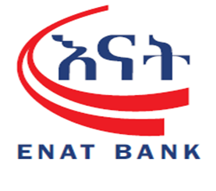

Factsheet for IT Operation and Service Delivery Audit Digital Banking Technologies Department Response

s/n | Condition and Criteria | Possible Cause, Effect and Recommendations | Auditee’s Response | Target Date / dependency
 | CONDITION  There is no documented role matrix for users on delivery channels back office.  CRITERIA  Enat Bank SC Information security procedure 2025 page 26 at 4.7.2 Separation of duties | EFFECT  - There will be Risk of unauthorized access, role overlap, and unclear accountability.  RECOMMENDATION  Role matrix should be designed and documented for digital banking platforms, clearly assigning responsibilities and segregation of duties. | We acknowledge the observation. Department will prepare formal role matrix document. | 1/1/2026
 | CONDITION  There is no developed, documented, or signed OLA (Operational level agreement) specifying service priorities, responsibilities, and timelines with Branch Operations and Digital Banking Operation.  CRITERIA  Enat Bank SC Digital Banking Service Policy 2024 page 6 at 8.4.2 Digital Banking Department | EFFECT  - Ambiguity in service expectations, inconsistent handling of branch issues and digital banking operation.  RECOMMENDATION  Develop, approve, and implement OLAs between branch operations and digital banking Technologies. | We acknowledge the observation. We will develop, document, and obtain approval for the OLA to clearly define service priorities, responsibilities, and timelines | 7/1/2026
 | CONDITION  The digital banking platform, Application system backups are not being taken to external or tape backups stored at an off-site and onsite location with External Hard disk.  CRITERIA  Enat Bank SC Information security procedure 2025 page 18-19 at 4.6.4 Backup and Recovery | EFFECT  - Risk of data loss or unavailability in case of hardware failure, fire, or other site disasters.  - Inability to restore services quickly following an incident.  RECOMMENDATION  Implement a regular backup schedule for the digital banking platform, including both onsite and offsite storage. | The issue will coordinating with the Atlas team and the Infrastructure team to back up on the tape. | 15/1/2026
 | CONDITION  User access to digital banking systems is not reviewed on a quarterly basis as required by IS Security policy.  CRITERIA  Enat Bank SC Information security procedure 2025 page 25 at 4.7.1 Account Management | EFFECT  - Increased risk of unauthorized access.  - Potential Segregation of Duties (SoD) violations.  RECOMMENDATION  Implement quarterly user access reviews for digital banking platforms (Clarification)and document the review process, findings, and corrective actions. | We acknowledge the observation. A User Access Review document for digital banking systems will be prepared | 21/2/2026
 | CONDITION  During the audit engagement, we observed gaps related to digital banking support including :  - No call log management, call-based case management, or resolution procedure exists for digital banking operations via the contact center.  - There is no centralized contact center to manage digital banking support requests.  - Complaint handling logbook and call log records for hotline 9845 (digital payment support) are not maintained.  CRITERIA  NBE Directive ONPS/02/2020 (Articles 18 & 19).  NBE Directive ONPS/09/2023 (Articles 12.2. i ) | EFFECT  Risk of unresolved issues, poor customer experience, and lack of accountability in digital banking operations.  RECOMMENDATION  Establish a centralized contact center for digital banking with call log management and call-based case management, or resolution procedure | The Bank is in the process of establishing a Call Center, which will be managed the  Call Center team. This will solve the issue and the support log issue will be handle.
 | CONDITION  The Digital platform Support, availability Uptime of digital platform, performance of digital banking support activities were not incorporated and doesn’t included in key performance indicators (KPIs) which shared as annual corporate Plan to Strategic and innovation department.  CRITERIA  NBE Directive SBB/083/2022 Page 2 Article 4.3 – I- VI. | EFFECT  - Lack of measurable metrics reduces accountability and prevents performance improvement.  - Management cannot make data-driven decisions on resource allocation or process improvements.  RECOMMENDATION  Include digital banking support metrics (e.g., response time and resolution time) in KPI dashboards. | The digital banking support metrics, including platform availability, uptime, and performance of support activities, are already incorporated in the Key Performance Indicators (KPIs) shared as part of the annual Corporate Plan with the Strategic and Innovation Department. Please refer to Appendix 9
 | CONDITION  Critical data such as EJ files and surveillance camera footage is not backed up on onsite or offsite storage.  CRITERIA  Enat Bank SC Information security procedure 2025 page 18-19 at 4.6.4 Backup and Recovery | EFFECT  - High risk of data loss, operational disruption, and inability to investigate incidents.  RECOMMENDATION  Implement regular backups for EJ files and camera footage, store them both onsite and offsite, and periodically test backup restoration. | The EJ backup is properly maintained; however, we have noted that some camera data has not yet been backed up, and we will correct this. The ATM and backup server are located in different sites, ensuring that the backup is stored off-site | 7/2/2026
 | CONDITION  Successful USSD top-up transactions do not include full information, such as amount, sender and receiver names.  Please see appendix 5  CRITERIA  NBE Directive ONPS/02/2020 (Articles 18) | EFFECT  - Customers cannot fully verify transaction details, increasing dispute risk.  - Reduced trust in digital payment systems.  RECOMMENDATION  Update the USSD platform to include complete transaction details (sender, receiver, and amount). | USSD transactions confirmation screen displays the Sender Account, Receiver Name, Receiver Account, Receiver Bank Name and Amount. Please see appendix 7
 | CONDITION  The payment receipt generated from the digital banking platform  - Does not include key transaction details such as the service charge amount to other bank and time stamp of transaction.  - On top of receipt address information the short code 9845 is not included.  - Lack of customer data protection like visibility of sender and receiver account.  Please see appendix 1  CRITERIA  NBE Directive ONPS/02/2020 (Articles 18)  NBE Directive ONPS/09/2023 (Articles 12.2. a-j ) | EFFECT  - Customers may not have full visibility of the total transaction cost.  - This can lead to customer disputes, lack of transparency, and non-compliance with NBE directives.  - It reduces the reliability of receipts as official evidence for audit or reconciliation purposes.  RECOMMENDATION  All digital and electronic receipts should display full transaction details including the service charge amount and time of execution. | The digital banking transaction receipts already include VAT and service charges handled by Enat Bank . please find the attached file. Charges for other bank transactions are managed by EthSwitch. We will continue to review receipt formats to ensure compliance with NBE directives.  Please see appendix 8
 | CONDITION  There is no user manual and administrative manual for back office system and delivery channel.  CRITERIA  Enat Bank SC Digital Banking Service Policy 2024 page 6 at 8.4.2 Digital Banking Department | EFFECT  - Lack of manuals may lead to inconsistent system operation and inefficient issue handling.  - New or replacement staff may experience delays in understanding system processes.  - Increases the risk of operational errors or unauthorized activities due to unclear procedures.  RECOMMENDATION  Develop and maintain User Manuals and Administrative Manuals for delivery channel back office | We acknowledge the observation. A user manual for branch operations has already been prepared and is available for sharing as needed.
 | CONDITION  The Electronic Journal (EJ) file is not configured to reflect all actual birr note denominations. Specifically, the 200 birr note is excluded from the combination matrix and also there were inconsistency of birr note denomination throughout the bank ATM EJ File configuration. And Customer Account information were not hidden or not Protect, it was visible on EJ file  Please see appendix 4  CRITERIA  Enat Bank SC Domestic Card Banking Procedure Manual 2024 page 21 at 4.3. E. ATM Cash loading | EFFECT  - Inaccurate cash reconciliation between ATMs and back-end reports.  - Increased risk of undetected cash mismatches and reporting errors.  - Potential customer disputes during withdrawal transactions.  RECOMMENDATION  Update the EJ file configuration to include all active birr denominations (including the 200 birr note) and validate the change through test transactions and reconciliation reports. | The EJ denomination configuration issue has been corrected  Regarding the visibility of customer account information in the EJ file, communication has been initiated with the Switch and CBS teams to address the issue and implement the necessary system adjustments to ensure account information is properly masked and protected in accordance with the Bank’s information security standards. | 30/2/2026
 | CONDITION  In the digital banking back office system user at Digital banking operation department users, the authorization tab allowed them to make amendments to customer data (e.g., phone and e-banking details) without enforcing a maker-checker control.  Please see appendix 2  CRITERIA  Enat Bank SC Information security procedure 2025 page 26 at 4.7.1 Account management  Enat Bank SC Mobile Banking and Mobile Wallet Operational Procedure Manual 2024 page 7 at 2.4 change of mobile phone number | EFFECT  - Risk of unauthorized or erroneous changes to customer profiles.  - Non-compliance with segregation of duties principles.  - Potential financial and reputational risk due to fraud or data tampering.  RECOMMENDATION  Implement a maker-checker workflow for all customer data amendments in the digital banking system, ensuring changes are independently verified before activation. | The maker-checker workflow for customer data amendments is already implemented in the digital banking back office system. Additional clarification or evidence can be provided upon request.
 | The Digital Banking Technology Department is performing unauthorized database administrative tasks such as executing DB backups and managing core databases, despite these duties not being part of their defined roles or approved access rights.  CRITERIA  Enat Bank SC Digital banking office job discerptions | EFFECT  This Situation demonstrates a violation of segregation of duties and access control principle with against of their Job description assigned by the bank  RECOMMENDATION  The department shall transfer all database management role, administrative credential task for the bank Database and MIS work unit. | Digital Banking technologies department has no core databases access.  Monitoring/Taking DBS Database backups should be Digital Banking Technologies Department duties,  please see the updated Job description.(Online system administration division)
 | Privileged accounts (Administrator, root and Service Accounts) are being operated without implementation of Left Security Operation (LSO) and Right Security Operation (RSO) controls, leaving privileged activities without required oversight and segregation of duties.  CRITERIA  Enat Bank SC Information security procedure 2025 page 26 at 4.7.1 Account management  Segregation of duties for privileged activities (NIST SP 800-53: AC-5, AC-6) | EFFECT  These security weaknesses create the potential for:  - Unauthorized access to critical systems  - Privilege misuse and insider threats  - Inability to trace privileged actions during incidents  RECOMMENDATION  - Formally implement RSO and LSO controls for all root and service account operations with Collaborating ISD  - Ensure privileged credentials are stored in a secured, sealed, controlled safe, with documented break-glass procedures  - Enforce dual-authorization for privileged command execution and emergency use  - Enable continuous monitoring and periodic review of privileged access activities | We acknowledge the audit observation; however, we would like to clarify that key Left Security Operation (LSO) and Right Security Operation (RSO) controls are already implemented within our privileged BO user management processes.  Specifically:  Dual authorization (maker-checker) is enforced for critical privileged actions, including digital banking activations and user administrative tasks. Approval workflows are in place.
 | CONDITION  In the Tele birr transaction report generated from the delivery channel back office, the transaction time is not included, which limits the accuracy and completeness of transaction details.  Please refer appendix 3  CRITERIA  Best practice | EFFECT  - Incomplete transaction data reduces the accuracy of reconciliations and audit trails.  - Difficulty in resolving customer complaints and disputes due to missing transaction time.  - Increased risk of operational and financial discrepancies.  RECOMMENDATION  The Tele birr transaction reporting should include the exact transaction time for all records generated in the delivery channel back office. | The Back office report is generated based on date-range input given. Therefore, only the transaction date is displayed as requested. The system records full timestamps internally, and detailed time data can be retrieved when required. And To apply this kind of functional requirement, time fetching data, system resource and performance related issues also be considered.

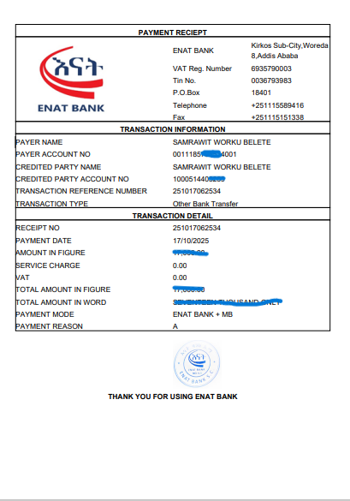

Appendix 1

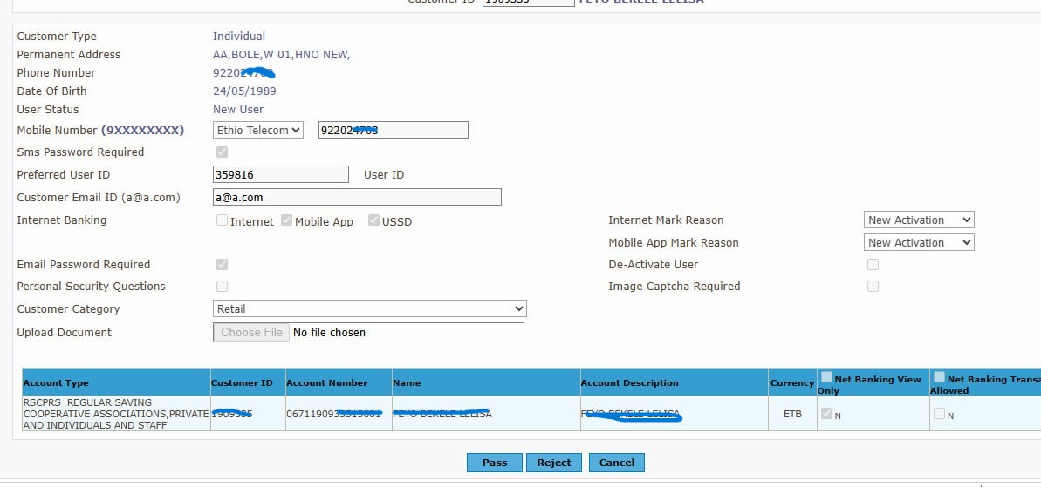
Appendix 2
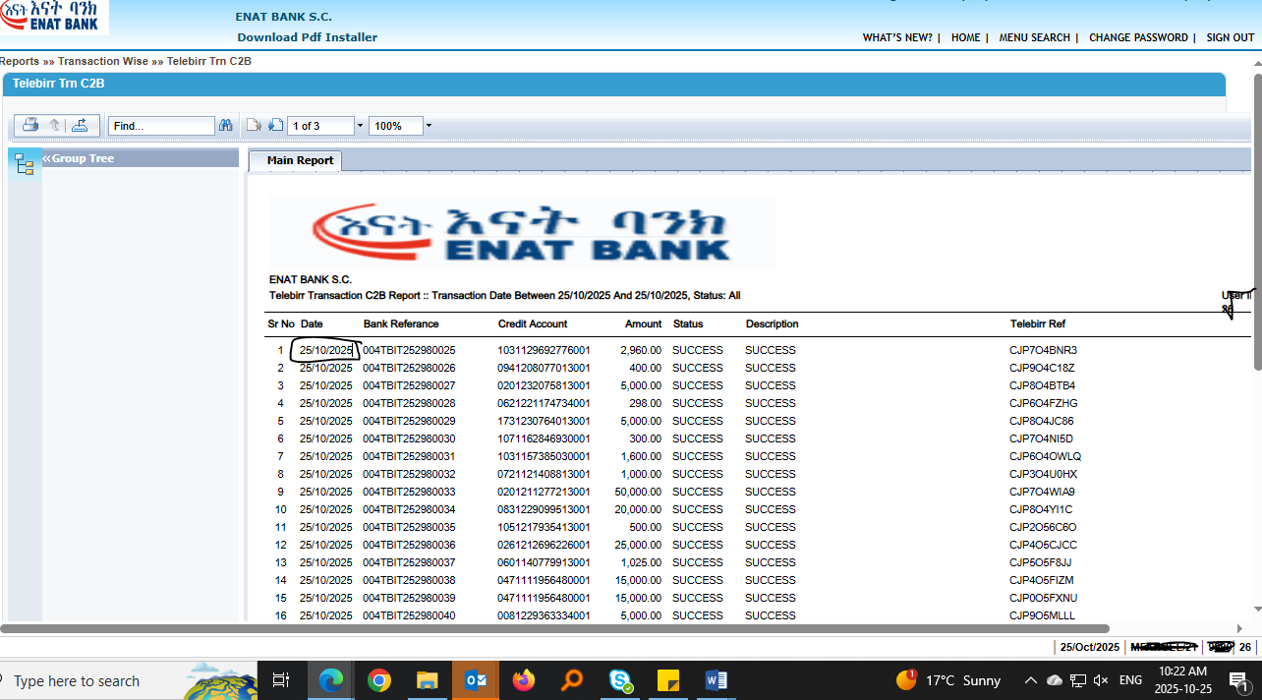
Appendix 3
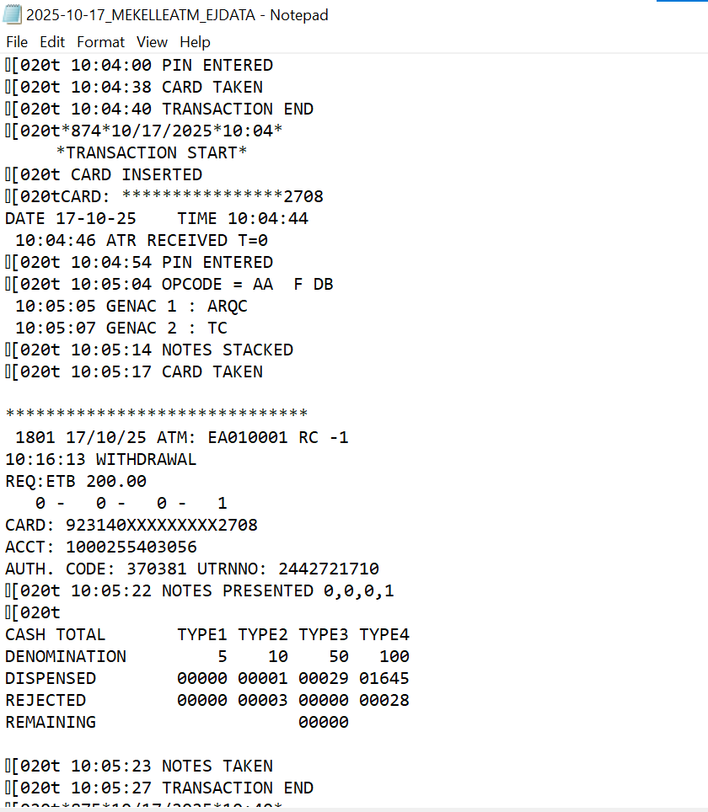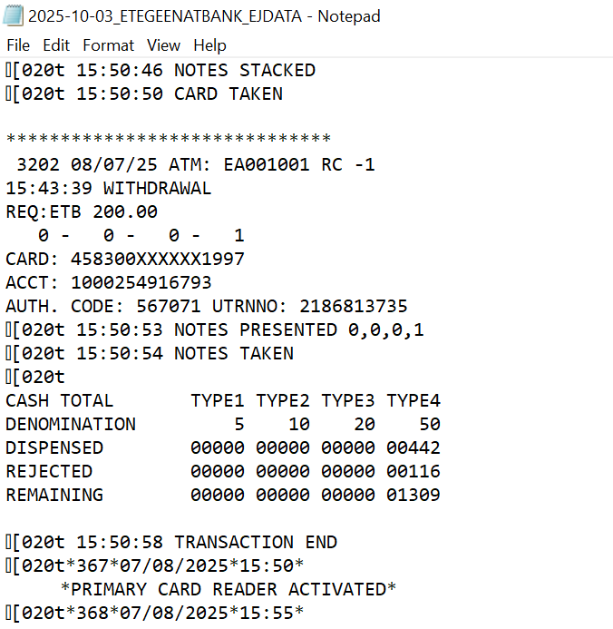
Appendix 4
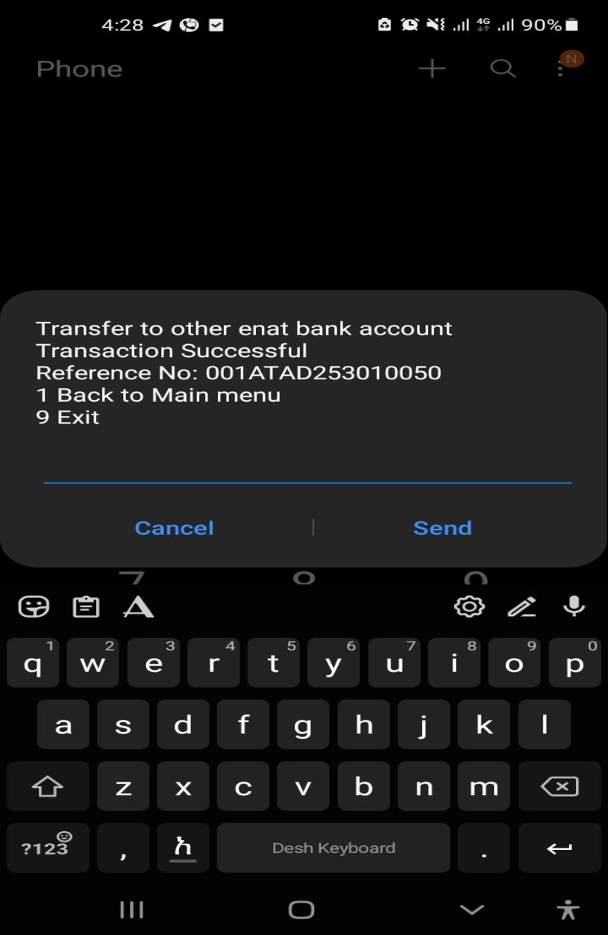
Appendix 5

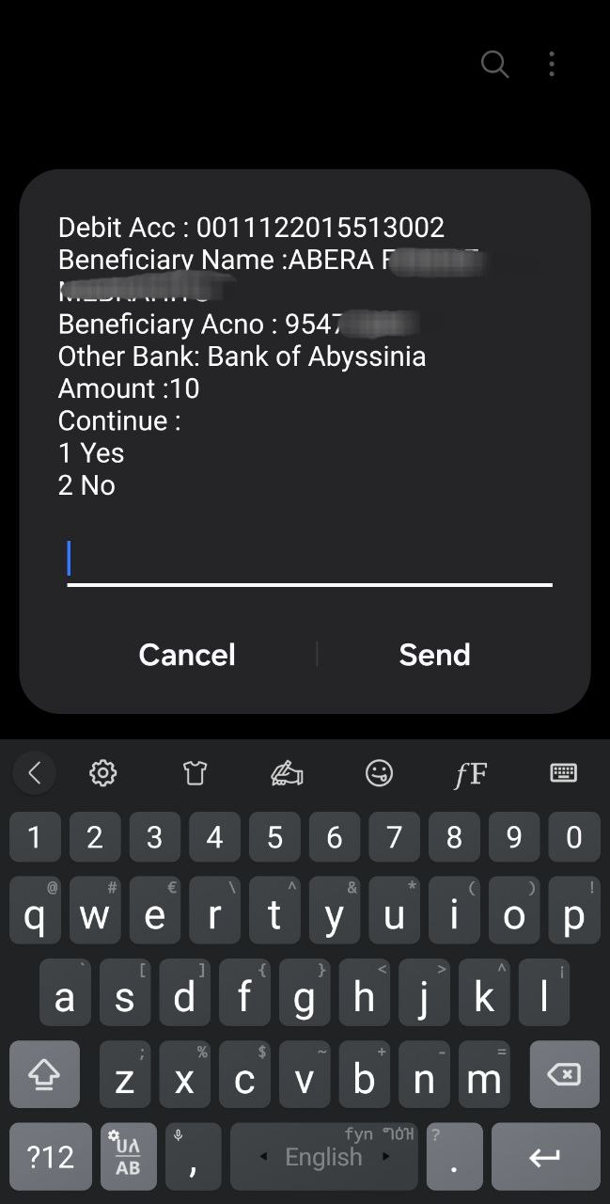
Appendix 7
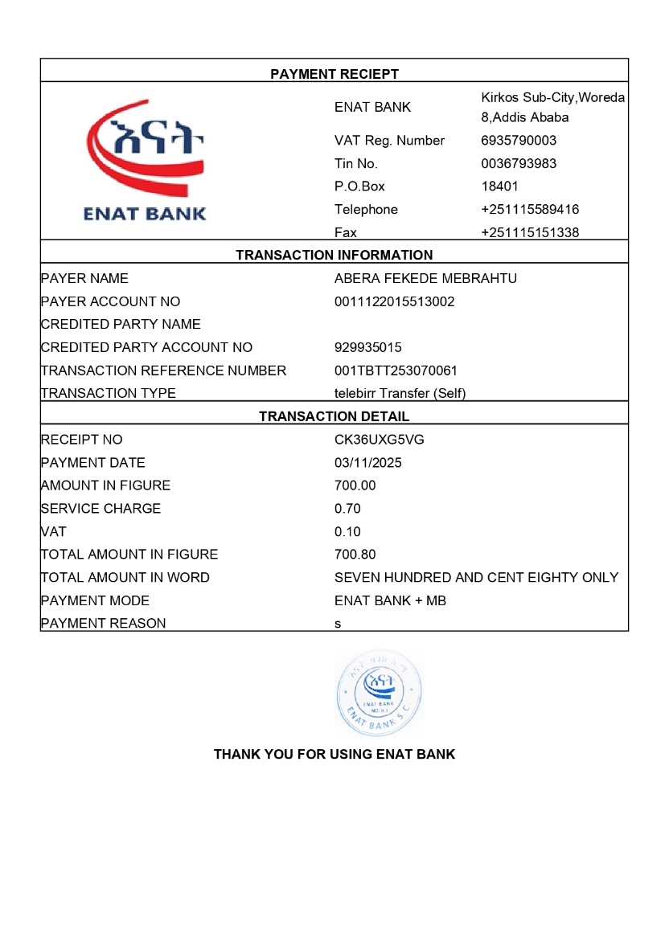
Appendix 8
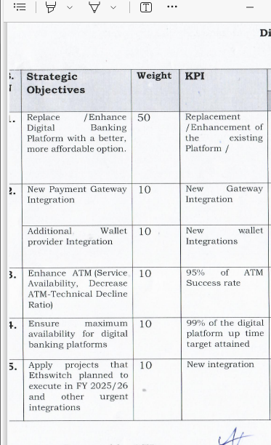
Appendix 9

